Hospital healthcare profile document

For hospitals it’s important to improve operational efficiency while maintaining the highest standard of patient care.

The challenge faced by the healthcare industry is to streamline its operations to deliver exceptional healthcare at a sustainable cost. This can be achieved by monitoring the various KPIs.

Dataset

Dataset contains one fact table and three dimension tables. The dimension tables contain details about the staff, departments and the beds.

Fact and Dimension model

Dimension tables:

1. Staff_detail: Staff_ID, Staff_name
2. Department: Dpt_ID, Department_name
3. Bed_detaiil: Bed_ID, Bed Number

Fact table columns:

1. Staff_ID
2. Bed_ID
3. Dpt_ID
4. ID
5. Name
6. Gender
7. City
8. State
9. Age
10. Patient type
11. Status
12. Treatmentcost
13. Bed
14. LOS
15. ER_time
16. Date
17. Feedback
18. Rating
19. Age Bucket
20. Custom
21. FZ me

The fact table has to be transformed in power query editor to make relevant modifications to the data to make it more useful.

Star Schema of the fact and dimension tables:

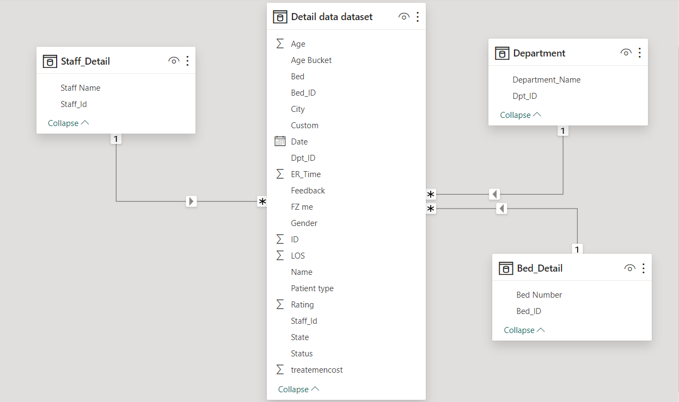

The general ER diagram for a healthcare database is as shown below:

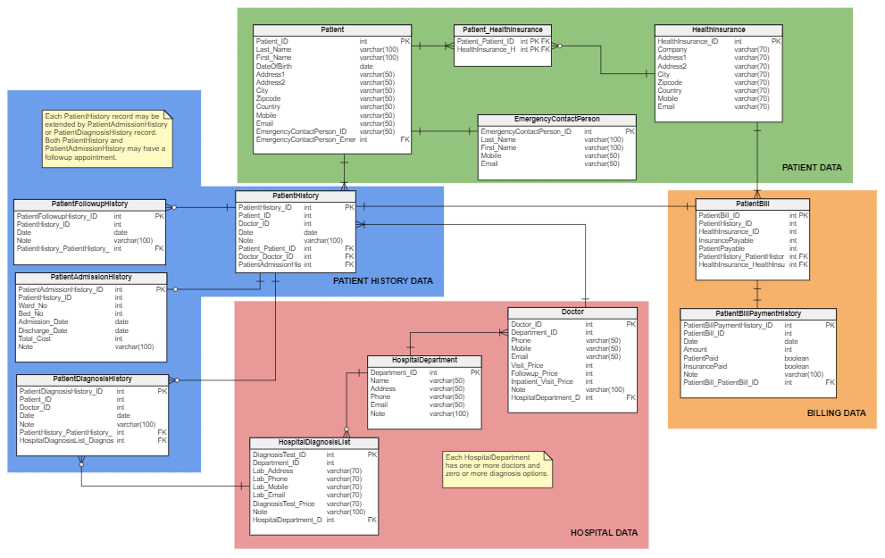

# **The following are the KPIs relevant to the healthcare industry with respect to this dataset**

1. Inpatient satisfaction rate

The inpatient satisfaction rate is an essential care quality metric that each and every healthcare business should be monitoring. It measures how happy and content patients are with the services being provided to them.

The inpatient satisfaction rate can be calculated through the below formula: (Higher number is desired)

**Inpatient Satisfaction Rate = (Number of satisfied patients / Total number of patients surveyed) * 100**

1. Average treatment cost

The average treatment cost is a financial metric that tracks how much a treatment costs to the hospital.

The reason behind monitoring average treatment costs is to identify any inefficiencies causing the hospital money. You can also calculate the treatment cost for different treatment types and age groups. This will help you budget better and optimize processes that optimize your spending.

The following formula can be used to calculate average treatment costs.

**Average Treatment Costs = Total treatment costs / Number of treatments**

1. Number of patients per medical staff

Having an optimal ratio will ensure your patients are treated well on time, and your medical staff isn’t left stressed out from dealing with back-to-back patients.

To calculate this ratio, use the below formula:

**Number of Patients per Medical Staff = Number of staff / Number of patients**

1. Bed occupancy rate

Taking a look at the bed occupancy rate will reveal the days of the month (or months of the year) when there are the most patients, and thus, more beds are occupied. This will help you pre-plan, so you don’t reach a stage where you’re out of beds for patients to be treated in.

To find out the bed occupancy rate for your healthcare business, use the below formula:

**Bed Occupancy Rate = (Number of occupied beds / Number of beds available) * 100**

1. Average hospital stay

The average hospital stay is a good indicator of how efficiently the hospital is run. This metric measures how long patients stay in the hospital on average.

Formula to calculate average hospital stay:

**Average Hospital Stay = Total length of stay of patients / Number of patients**

If patients are staying longer than they should be, then there may be room for improvement. Conversely, if patients are leaving sooner than expected, then you may need to look into why that is the case. Tracking this KPI over time can help you make informed decisions about how to improve your hospital’s operations.

To get the most from this metric, calculate it for different treatment types. Some treatments require more intensive care and hence, a longer stay in the hospital.

Doing this will help you pre-plan how long patients are expected to stay, and if they stay longer than that, you can analyse what went wrong.

1. ER duration of treatment

As the name implies, the ER duration of treatment measures how long treatment takes in the ER. This is one step ahead of the ER wait time, and tracking both these metrics will result in operational efficiency, a calm emergency room, and satisfied patients.

The ER duration of treatment can be figured out by using the below formula:

**ER Duration of Treatment = Time when treatment starts – Time when treatment ends**

The ER witnesses a constant inflow of patients, and you’d want to optimize the treatment duration to treat more patients. However, don’t look to reduce the duration time to the extent that patients aren’t given their due treatments, and they have to be readmitted later on.

1. Bed turnover rate

This operational healthcare metric deals with how quickly patients move in and out of your hospital/clinic. It measures how equipped the facility is to take more patients. If the percentage is low consistently, then efforts need to be made to a) increase the number of beds/rooms or b) evaluate if patients are being asked to stay for longer than what is required.

Secondly, measuring the bed/room turnover rate enables you to align the cleaning team to prepare the room for the next patient. This step is crucial because it can reduce the risk of infection spread.

The bed or room turnover can be calculated through the below formula.

**Bed or Room Turnover Rate = (Number of discharges / Number of beds) * 100**

1. Ratio of ICU patients

Number of ICU patients/Total number of patients

DAX needed

Sum, Sumx

Calculate

Count

Average

Divide

Dateadd

Month, Year

KPI link : [18 Healthcare Key Performance Indicators to Include in a KPI Dashboard (databox.com)](https://databox.com/healthcare-kpi-dashboard#:~:text=A%20healthcare%20KPI%20%28key%20performance%20indicator%29%20is%20a,operational%20efficiency%2C%20quality%20of%20care%2C%20financial%20performance%2C%20etc.)

ER diagram: [ER Diagram for a Hospital Management System | Vertabelo Database Modeler](https://vertabelo.com/blog/er-diagram-for-hospital-management-system/)

<https://docs.google.com/document/d/1KMrxBtERAE_OBxqtSWw_PfeKlh4bQZGd/edit?usp=sharing&ouid=110447473828503419804&rtpof=true&sd=true>

<https://drive.google.com/drive/folders/18HYnthB9TAq-aKjmlF43dZR1H9yAGWXf?usp=sharing>